|  |  |
| --- | --- |
|  | FPT ACADEMY INTERNATIONAL  FPT – APTECH COMPUTER EDUCATION |

Address: 391A Nam Ky Khoi Nghia St., District 3, Ho Chi Minh City, Viet Nam.



|  |  |  |
| --- | --- | --- |
| Supervisor: | Phạm Thị Lánh | |
| Term: | 1 | |
| Batch No: | T1.2208.E0 | |
| Group No: | 3 | |
| Order: | Full name | Roll No. |
| 1. | Đỗ Thanh Hùng | Student1409691 |
| 2. | Cao Thị Minh Tâm | Student1407962 |
| 3. | Nguyễn Vũ Anh Tuấn | Student1405211 |

Month 11 Year 2022

This is to certify that

**Mr. ĐỖ THANH HÙNG**

**Ms. CAO THỊ MINH TÂM**

**Mr. NGUYỄN VŨ ANH TUẤN**

Have successfully Designed & Developed

**NAILERY**

Submitted by: **Ms. PHAM THI LANH**

Date Of Issue: November, 2022

Authorized Signature:

# Content

Content 3

Acknowledge 5

Synopsis 6

REVIEW 1 7

Problem Definition 8

Requirements Specifications 9

Architecture and Design of the project 10

Site map 11

Website Design Layout 12

I. Homepage 12

II. Collections 14

III. Product Category 14

IV. Cart 15

V. Check-out 16

VI. About us 17

VII. Contact 18

VIII. Sign Up 19

IX. Sign In 20

Task Sheet 25

REVIEW 2 26

WEBSITE USER INTERFACE 27

I. Homepage 27

II. Collections 29

III. Product Category 30

IV. Cart 30

V. Check-out 32

VI. About us 33

VII. Contact 34

VIII. Sign Up 35

IX. Sign In 36

Task Sheet 40

Testing document 41

Final checklist 42

# Acknowledge

As we understand that the eProject is a step-by-step learning environment that closely simulates the classroom and Lab based learning environment into actual implementation. It is a project implementation at your fingertips!! An electronic, live juncture on the machine that allows you to.

✓ Practice step by step i.e., laddered approach.

✓ Build a larger, more robust application.

✓ Usage of certain utilities in applications designed by the user.

✓ Single program to unified code leading to a complete application.

✓ Learn implementation of concepts in a phased manner.

✓ Enhance skills and add value.

✓ Work on real life projects.

✓ Give a real-life scenario and help to create applications more complicated and useful.

✓ Mentoring through email support.

We would like to send a great thank to our professor and others student for the adorable support during the time in the project.

Beside several mistakes we had made in the project, we hope to have more opportunities to widen our knowledge in the web developing world.

We also thank you so much for your information and the “demo” project from India APTECH to help us get more reality experience in this project. Since we have gained more experience from this project, we will not stop learning anything as much as we can to be more successful in the future.

Your Sincerely,

Group 03.

# Synopsis

- This project The Objective of this program is to give a sample project to work on real life projects. These applications help you build a larger, more robust application.

- The objective is not to teach you JavaScript/Dreamweaver but to provide you with a real life scenario and help you create basic applications using the tools.

- You can revise the topics before you start with the project.

- This project is meant for students who have completed the module of HTML5.

- These programs should be done in the Lab sessions with assistance of the faculty if required.

- The website (in this project) is a tool that help the company to access the

international market and gain more and more new customers.

- It is very essential that a student has a clear understanding of the subject.

# REVIEW 1

## Problem Definition

Nail art is a creative way to paint, decorate, enhance, and embellish the nails. It is a type of artwork that can be done on fingernails and toenails, usually after manicures or pedicures. Manicures and pedicures are beauty treatments that trim, shape, and polish the nails. Often, these procedures remove the cuticles and soften the skin around the nails. Types of manicures can vary from polish on natural nails to dipping powder and acrylic nails.

The nail-care industry has been growing like never before ever since the invention of modern nail polish.

Nail art is also a way to create its own identity through fashion, using colors and shapes as a disruption of childhood and entering to the female teen/adult world, also leaving the influence of their parents to create their own selves.

Here we are aiming to design a website “NailArt” which will provide an easy way to learn nail art with various designs and steps involved.

## Requirements Specifications

|  |
| --- |
| WEBMASTER: |
| Input:  ● Control website database, input product information … |
| Process:  ● Analyze website |
| Output:  ● Website interface, images, forms, …  ● Giving interaction |

|  |
| --- |
| HARDWARE / SOFTWARE REQUIREMENT: |
| Software:  ● Notepad/HTML editor  ● Dreamweaver  ● IE 5.0/ Netscape 6.0 |
| Hardware:  ● A minimum computer system that will help you access all the tools in the courses is a Pentium 166 or better  ● 64 Megabytes of RAM or better |

## Architecture and Design of the project



## Site map

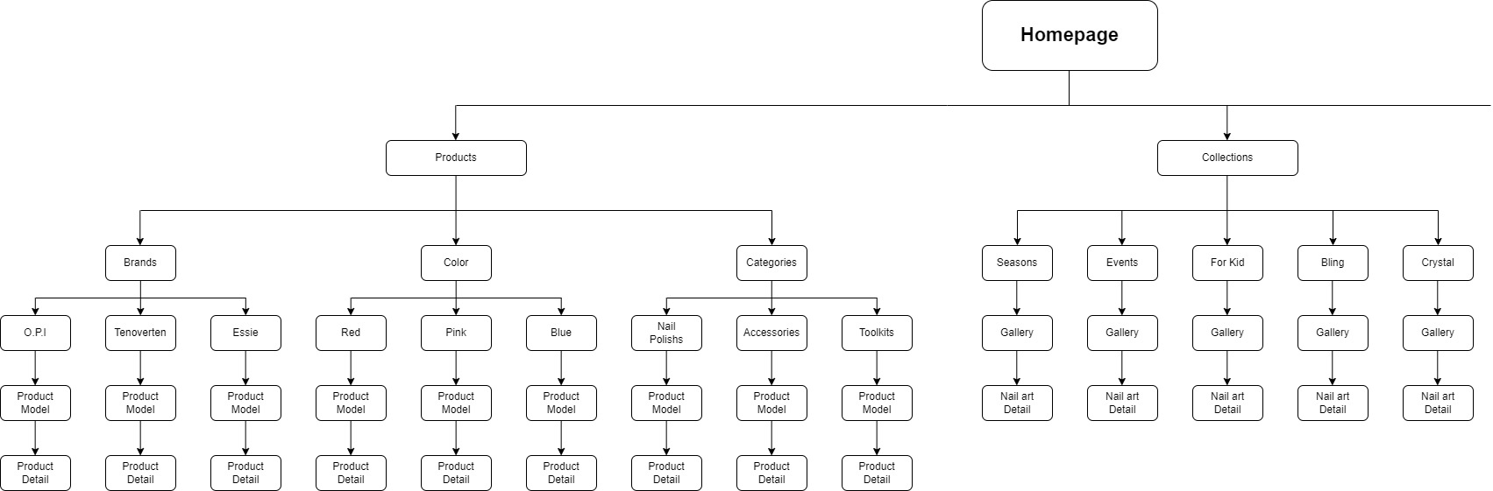

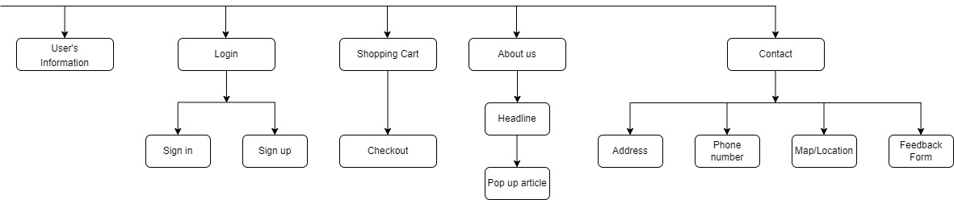

## Website Design Layout

### Homepage

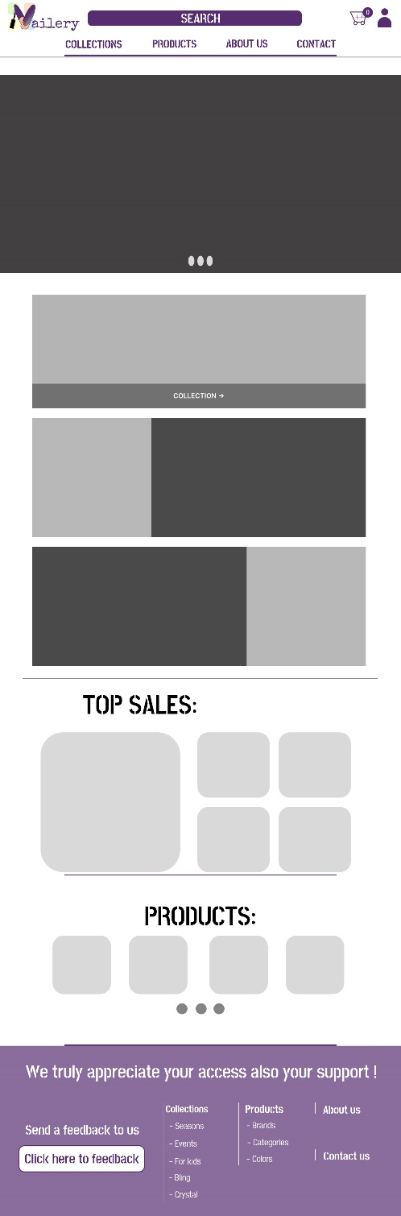

**Description:** This is a homepage of Nailery, the top of this page is a header, after that is a navigation bar. The main part of a homepage beside the slider also includes 2 sections: top sellers and new product. The footer of a homepage has a vertical navigation bar.

### Collections

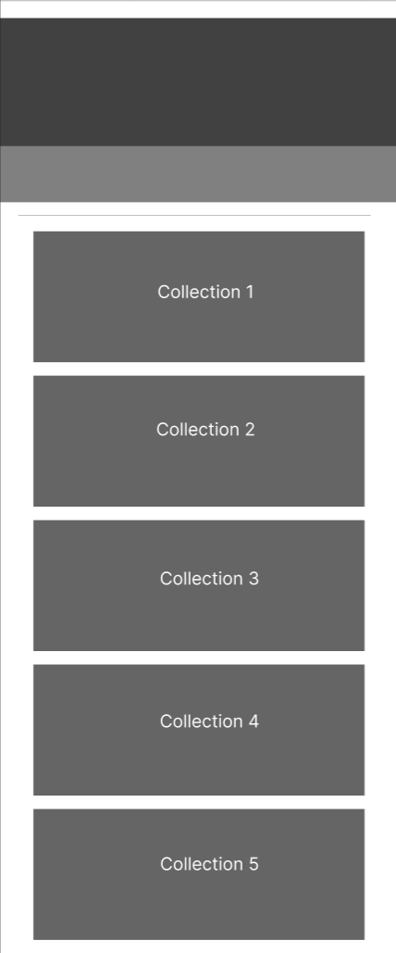

**Description:** When the user clicks on collections tag in navigation, it leads to a collections page. This page contains 5 categories of nail art design.



**Description:** When the user clicks on any kind of collection, it leads to a gallery page.

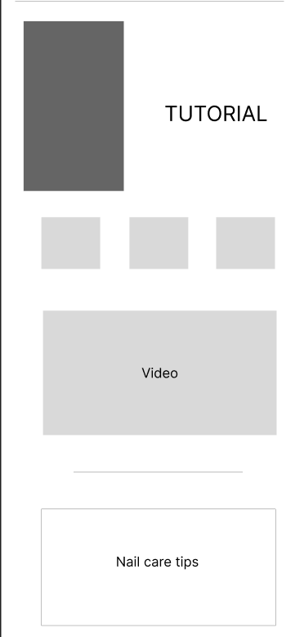

**Description:** When the user clicks on picture, there is nail art information page. This page contains tutorial of nails art, picture, video and nail care tips sections.

### Product Category

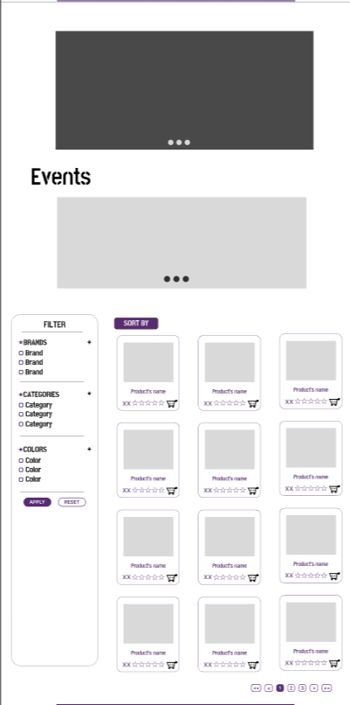

**Description:** When the user clicks on a Products tag on navigation, it will lead to this page. The left part is a filter which contains filters by brands, categories, colors. The right part is a result of a specific product.

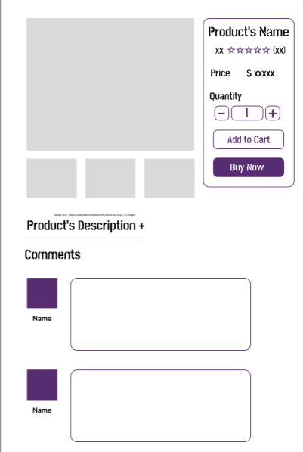

**Description:** When the user clicks on a Product’s picture or name, it will lead to product’s details page. Beside detail information about the product, it also contains Call to Action buttons Buy now. Moreover, it also contains the Reviews part, this includes reviews of the other buyers, and the user can write reviews about this product.

### Cart

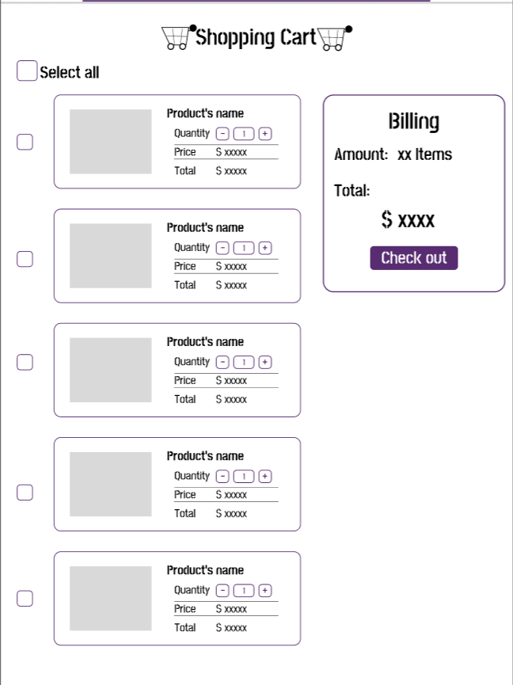

**Description:** When the user clicks on the cart icon in the header, the cart information will appear. It includes products that users have already added to cart, the user can select all items, remove items or reduce number of items which they don’t have the intention to buy.

### Check out

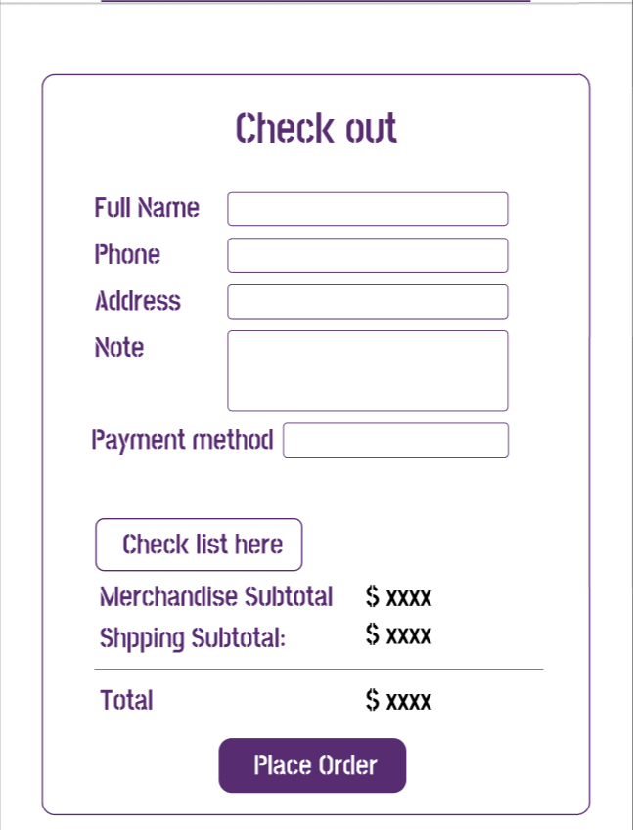

**Description:** After clicking the Checkout button on the Cart or Buy now button in Product Detail Page, the user will be redirected to checkout page. This page contains a form which requires the user to enter information. Below is total amount which customer will paid and Place Order button.

### About us

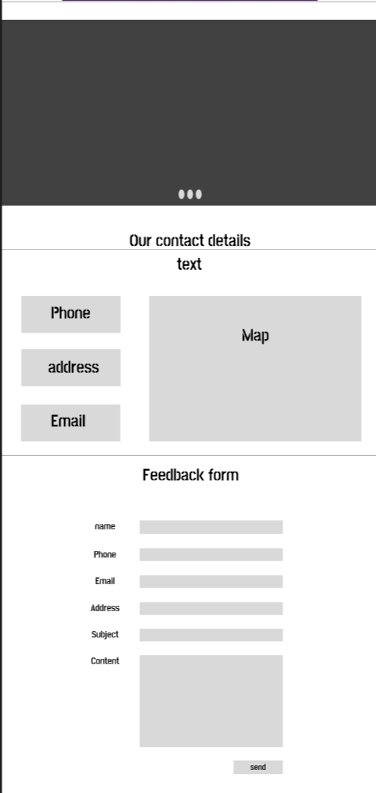

**Description:** When the user clicks on About us tag in navigation, it leads to the About us page. This page contains detailed information about Nailery.

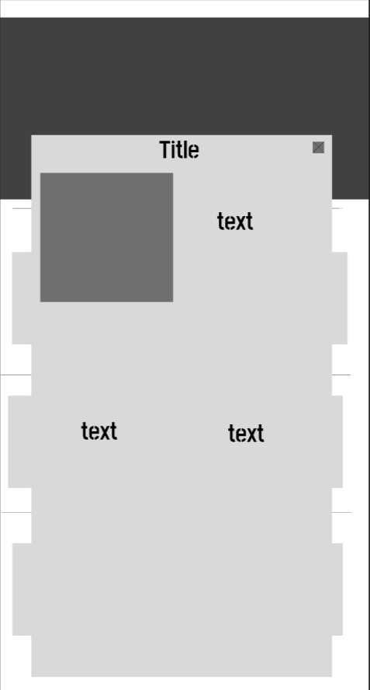

**Description:** When the user clicks on any text section, there will show a pop-up information box.

### Contact

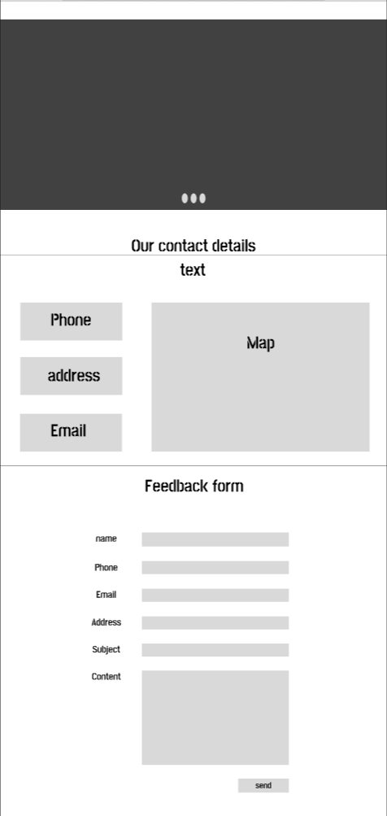

**Description:** After clicking the Contact tag on the navigation bar, the user will be directed to this page. The first part of this page is Nailery information (phone, address, email), beside it is a map with location of Nailery store. The next part of this page is a Feedback form to send customer’s feedback with required input information: name, phone, email, address, subject and content. Finally, it is a Send button.

### Sign up

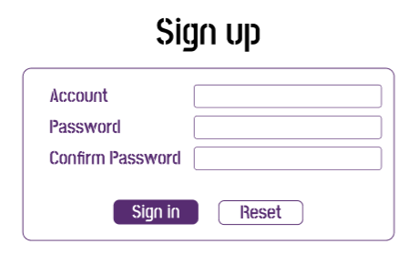

**Description:** User can sign up to create account for shopping in Nailery. When user clicks on the human icon in the header, it leads to a sign up page. User must put in required information such as account, password and confirmed password to register.

### Sign in

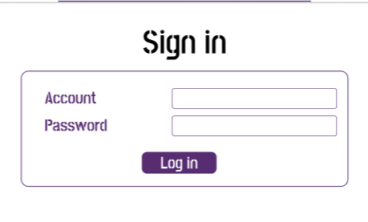

**Description:** User can sign in with account and password which has been registered before.

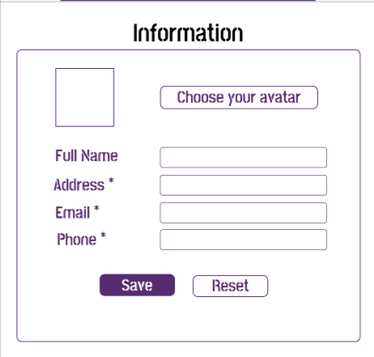

**Description:** User can update profile information such as name, address, email, phone number and avatar.

## Task Sheet

|  |  |  |  |  |  |  |
| --- | --- | --- | --- | --- | --- | --- |
| **Project Ref No.** | **Project Title – Ask Me Mobile** | **Activity Plan Prepared by** | **Date of preparation of Activity Plan** | | | |
| **Task** | **Actual Start Date** | **Actual Days** | **Teammate Names** | **Status** |
| Brainstorming ideas for layouts and Project Object | | Hùng, Tâm, Tuấn | 01/11/2022 | 3 days | Hùng, Tâm, Tuấn | Completed |
| Draw site maps and architecture design | | Hùng, Tâm, Tuấn | 04/11/2022 | 7 days | Hùng, Tâm, Tuấn | Completed |
| Wire framing general page layout | | Hùng, Tâm, Tuấn | 04/11/2022 | 7 days | Hùng, Tâm, Tuấn | Completed |
| Collect static assets (pictures, mp4, documentation…) | | Hùng, Tâm, Tuấn | 04/11/2022 | 7 days | Hùng, Tâm, Tuấn | Completed |

**REVIEW 2**

# WEBSITE USER INTERFACE

### Homepage



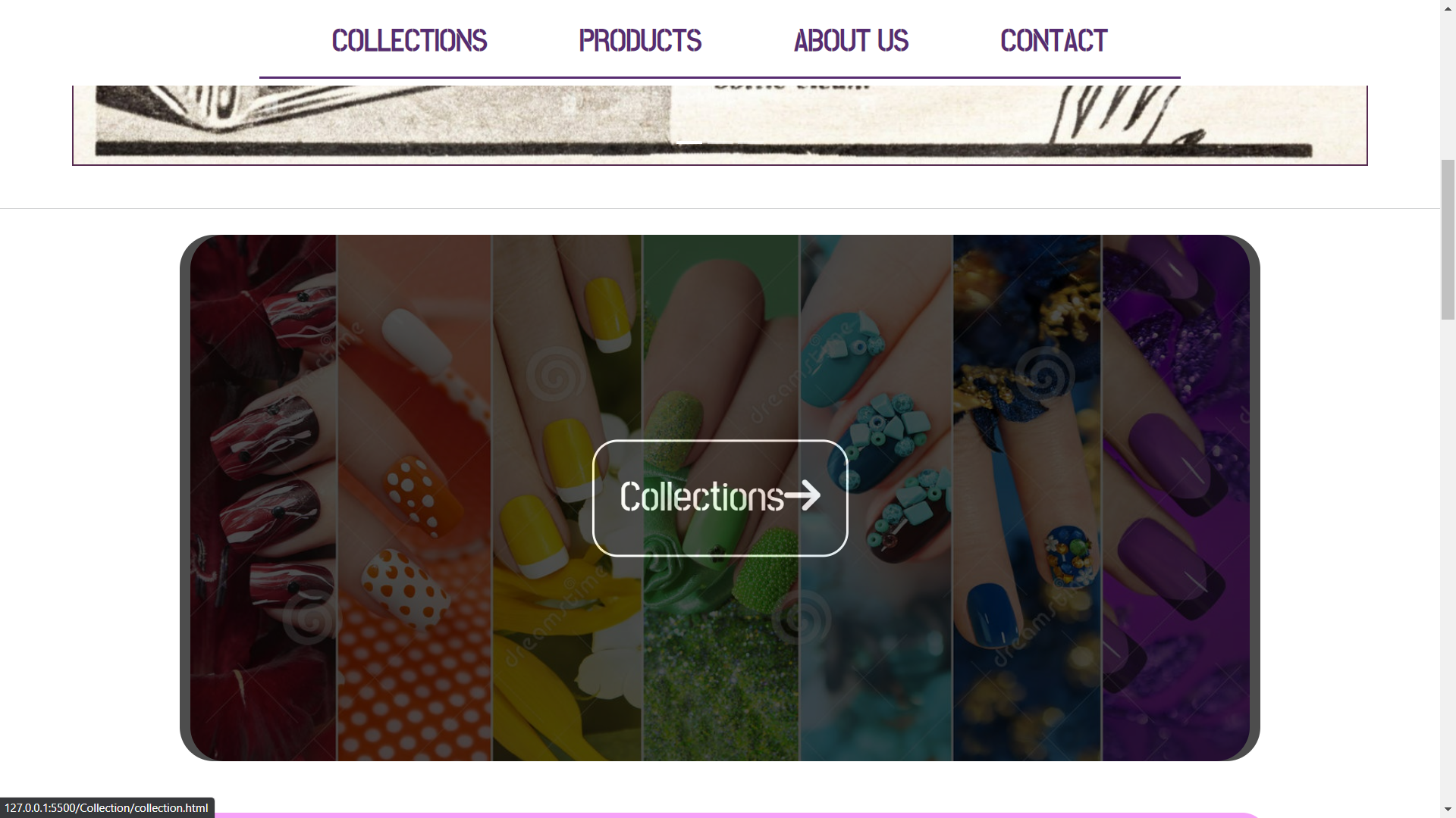

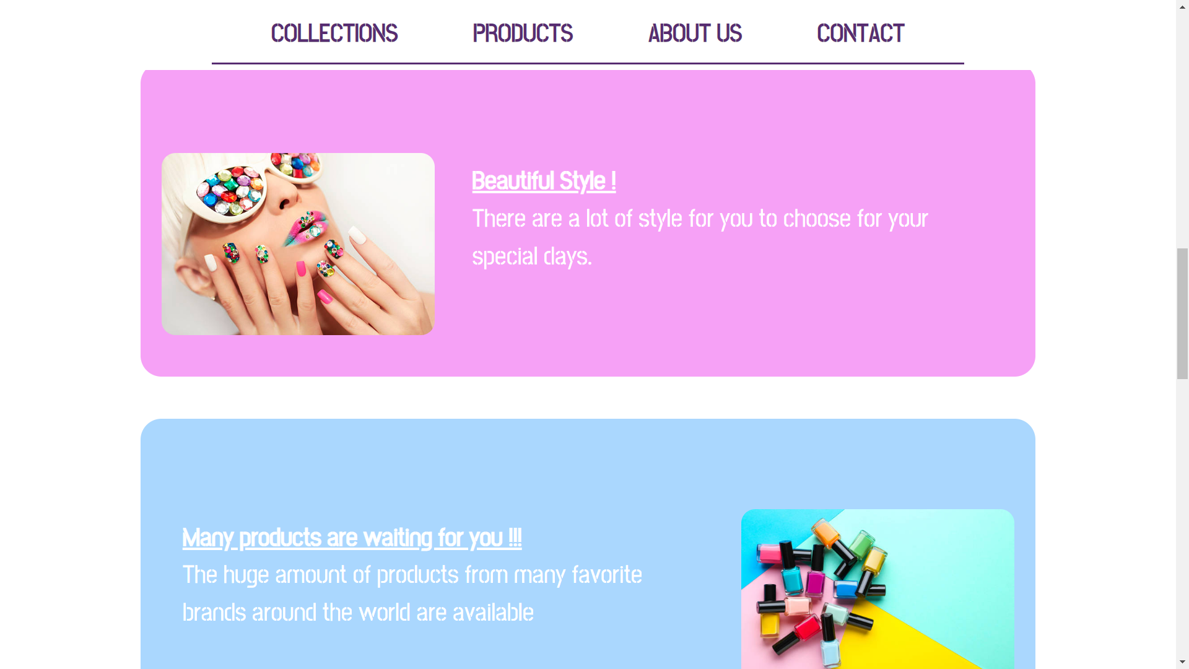

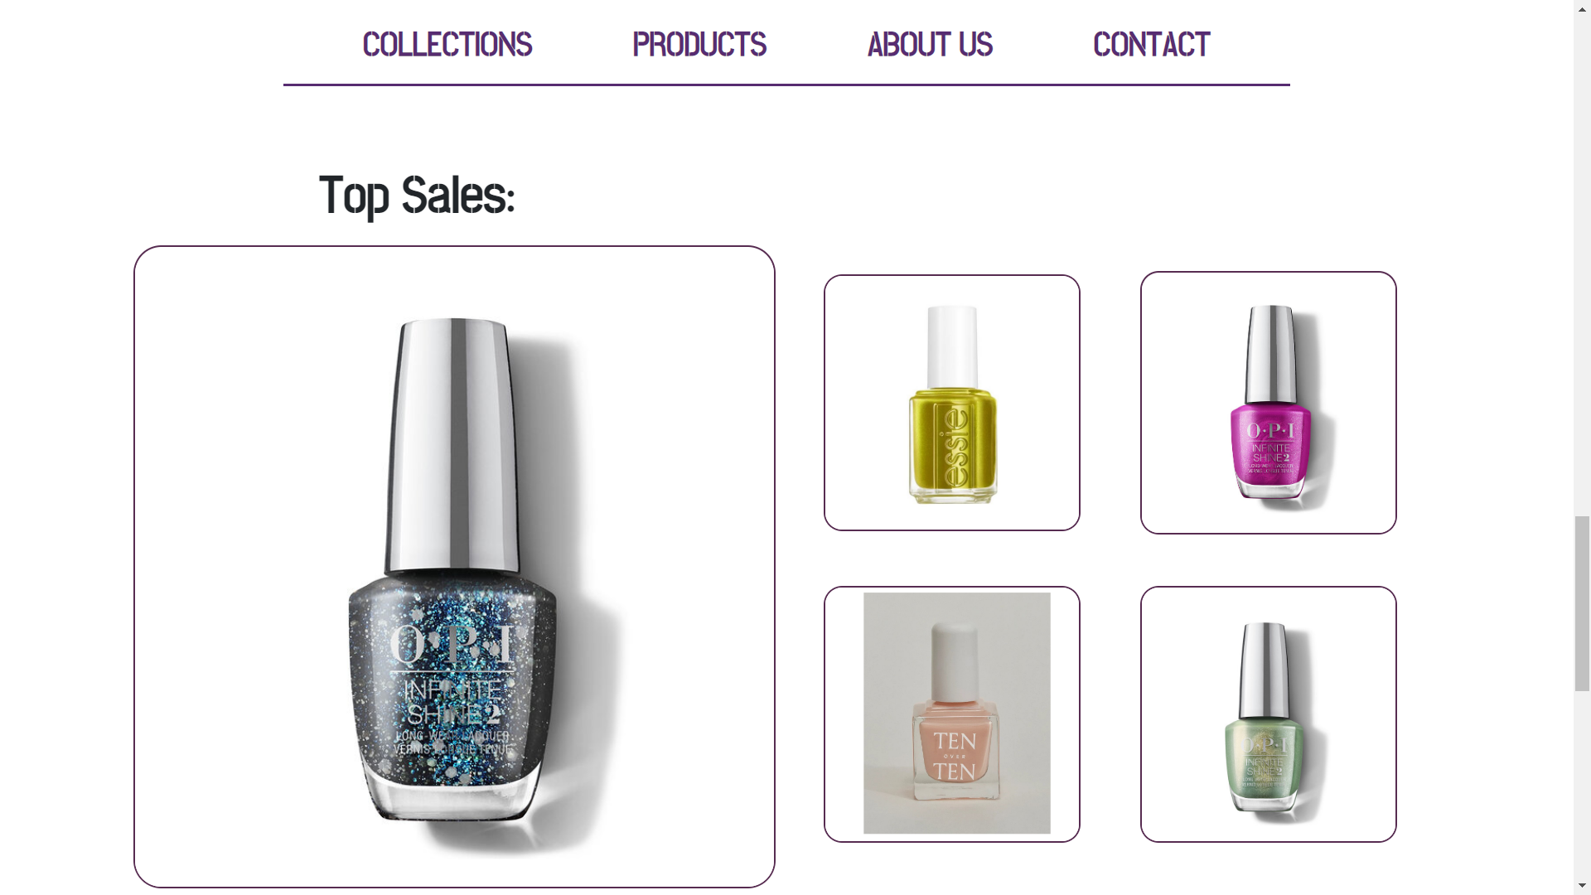

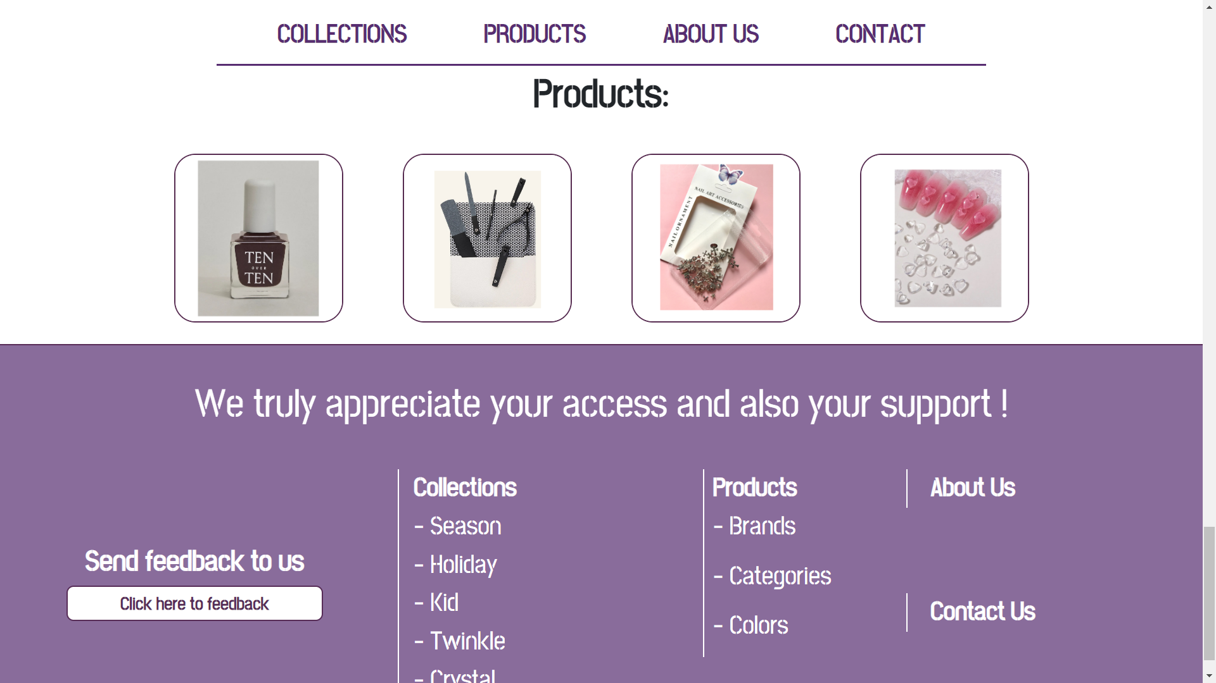

### Collections

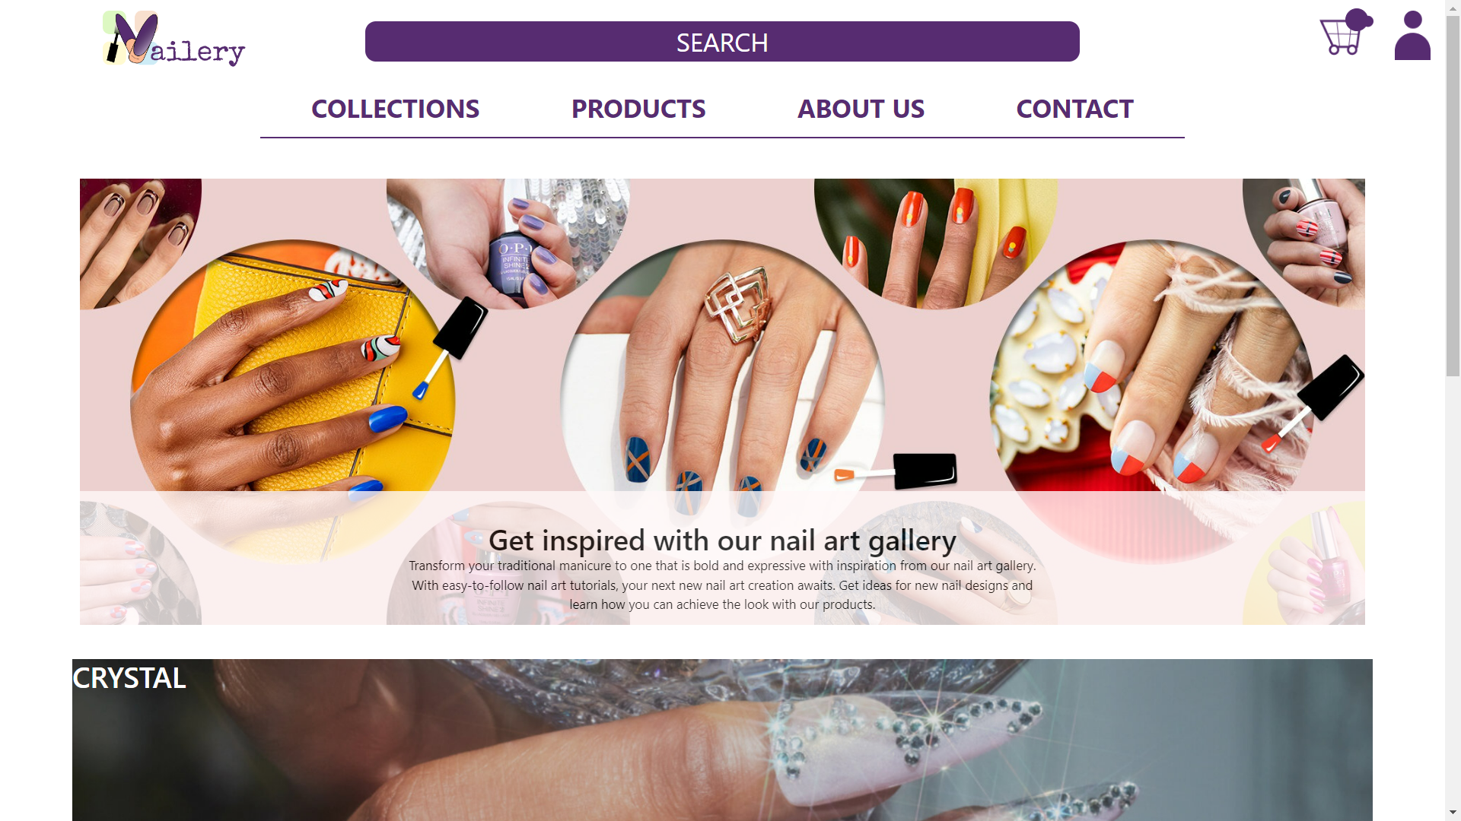

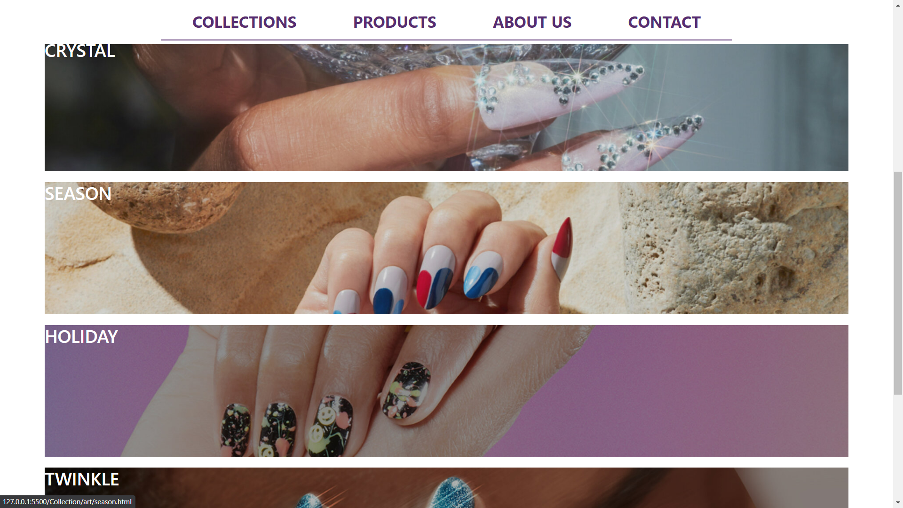

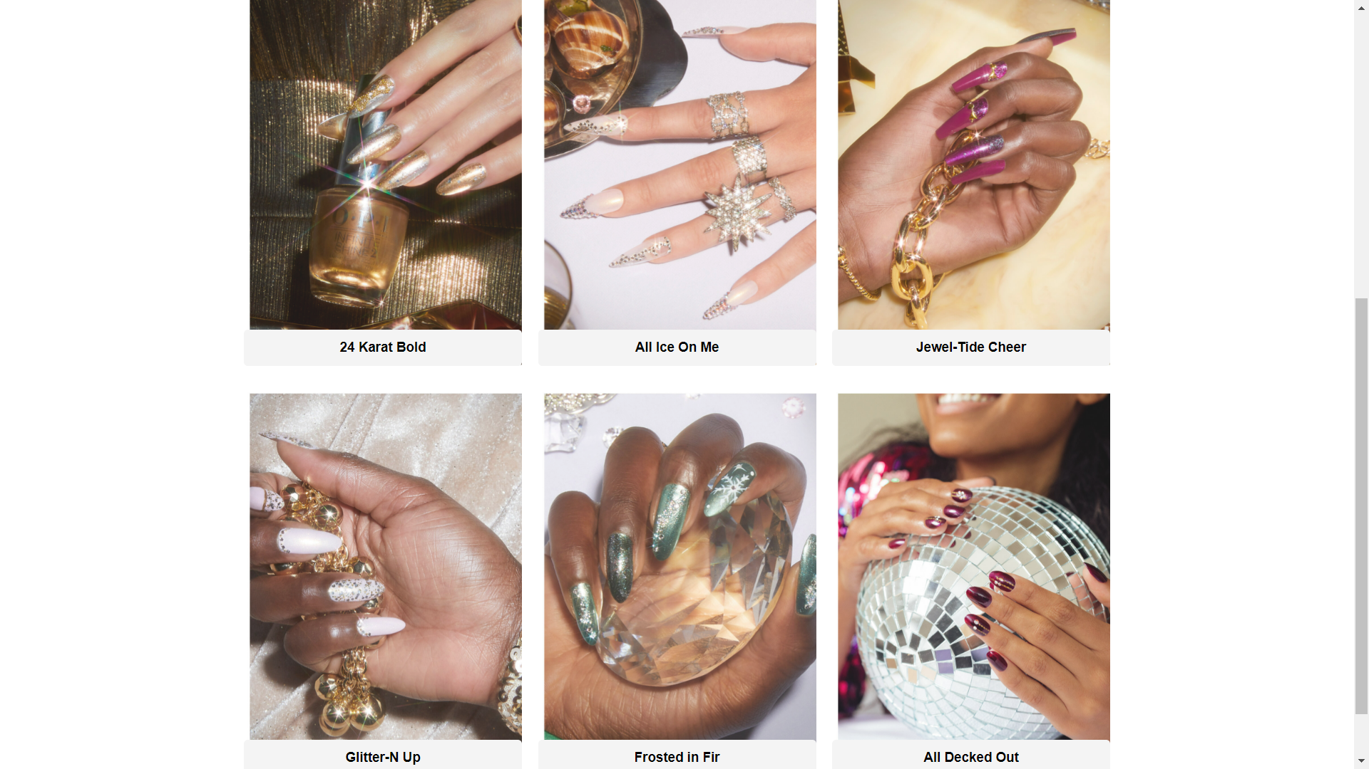

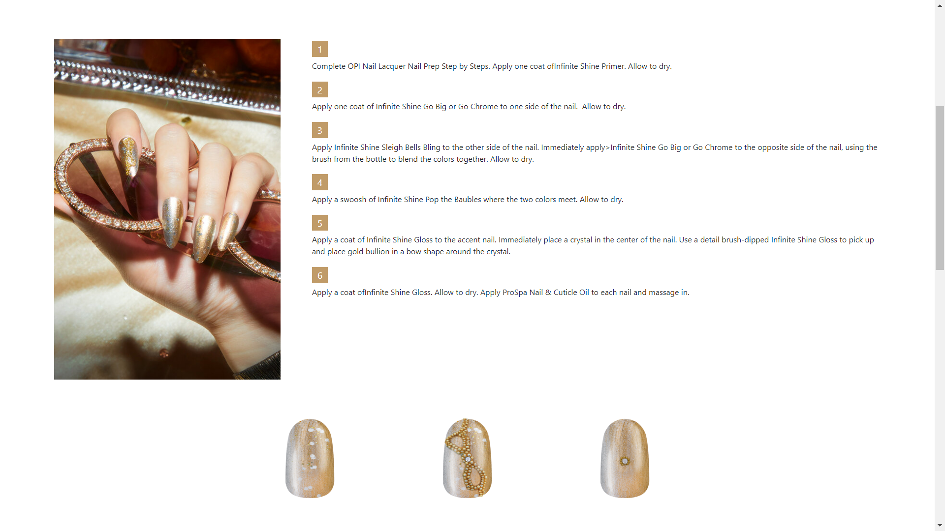

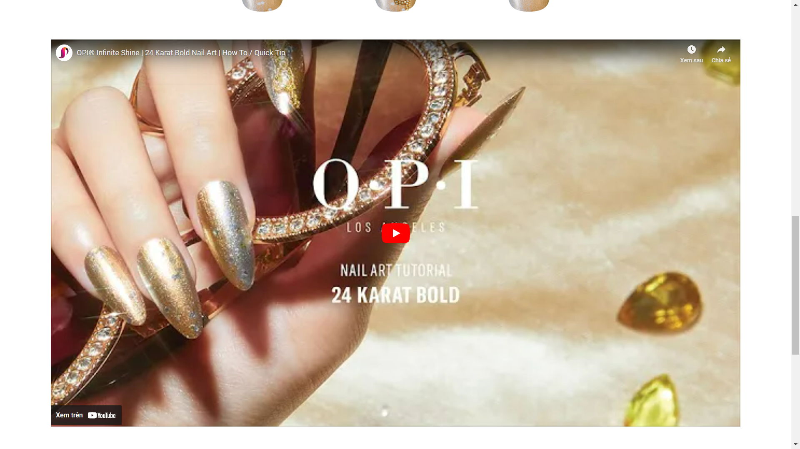

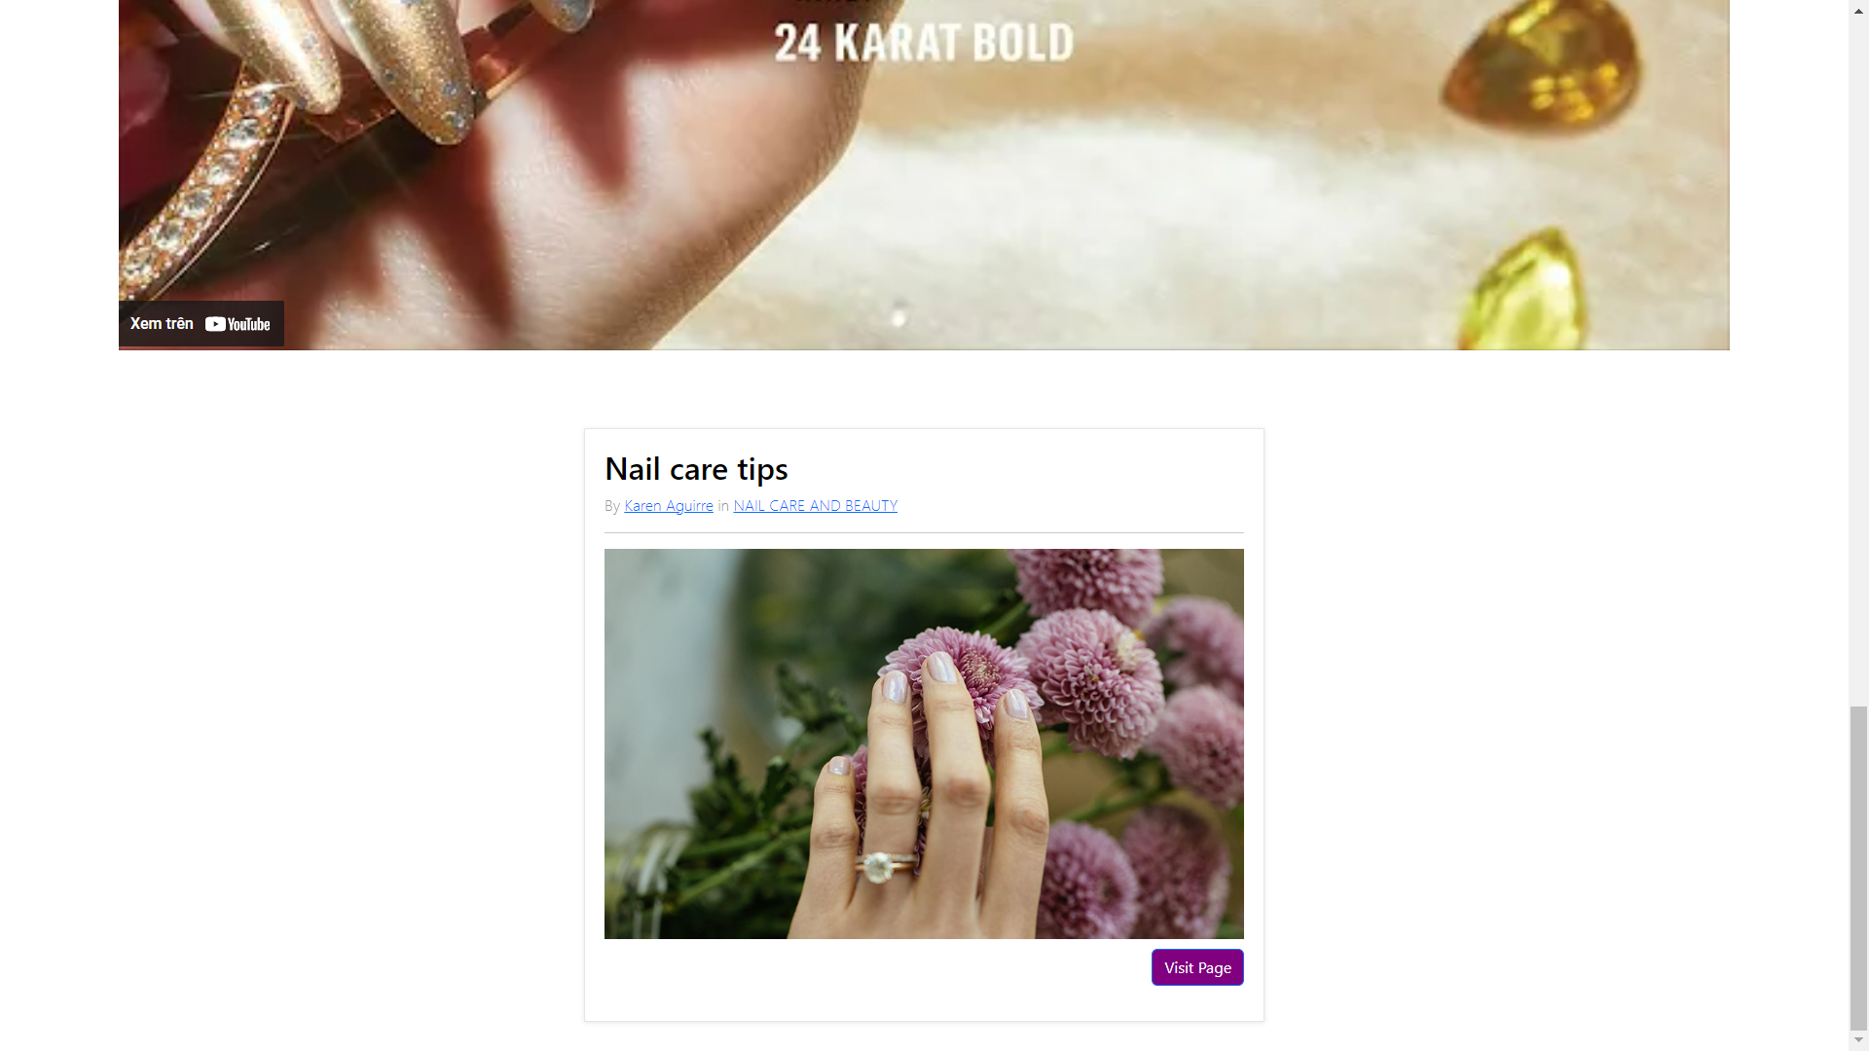

### Product Category

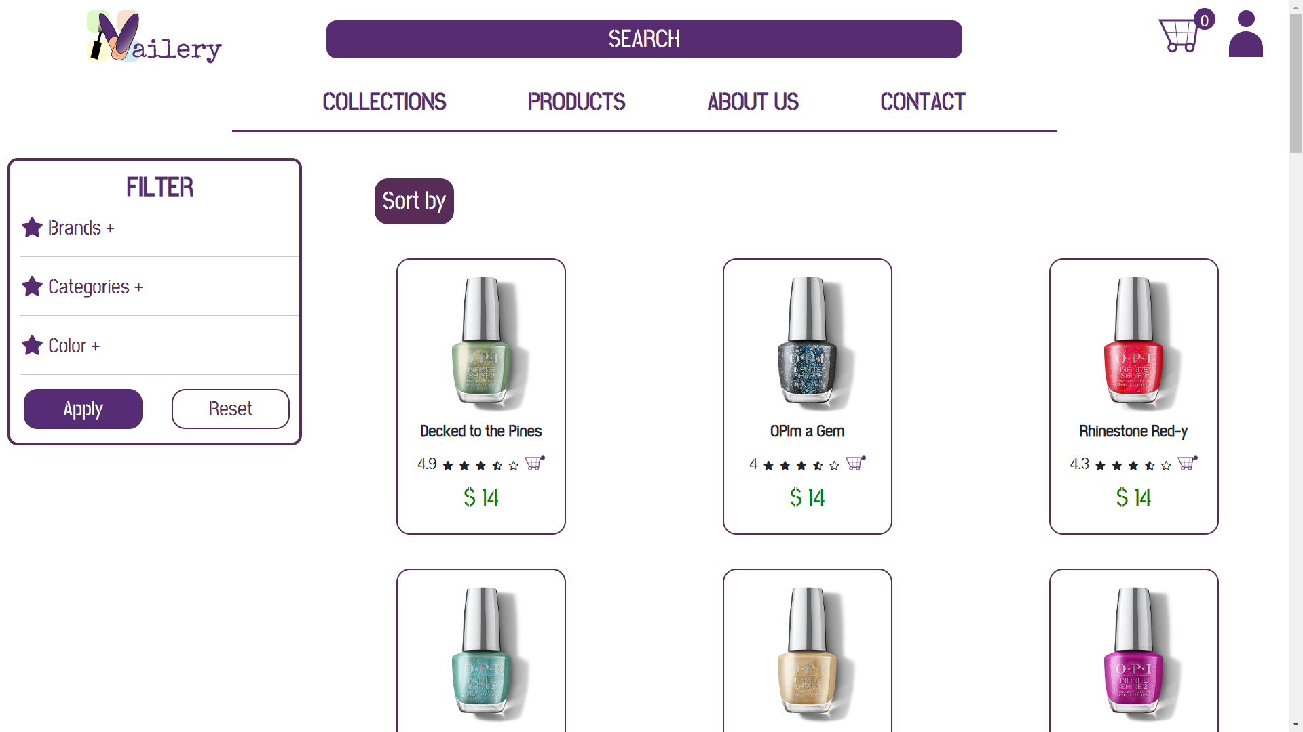

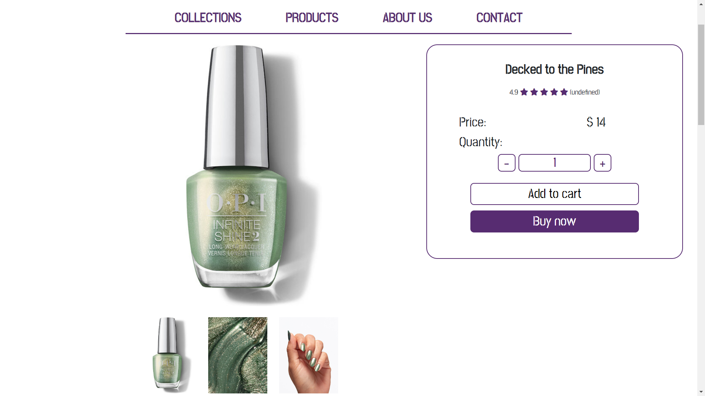

### Cart

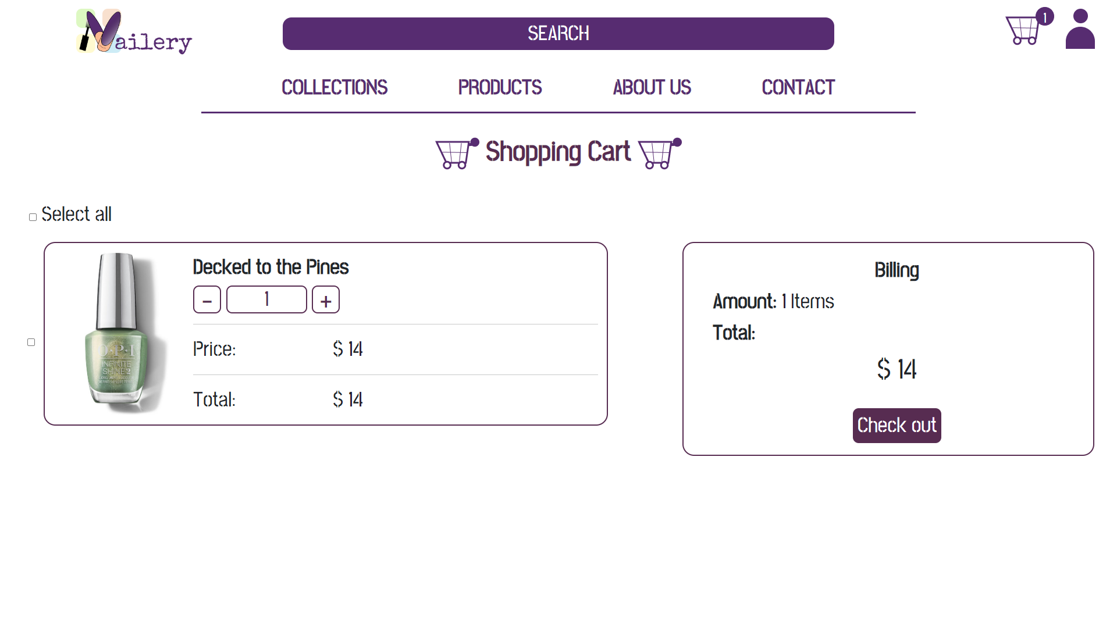

### Check out

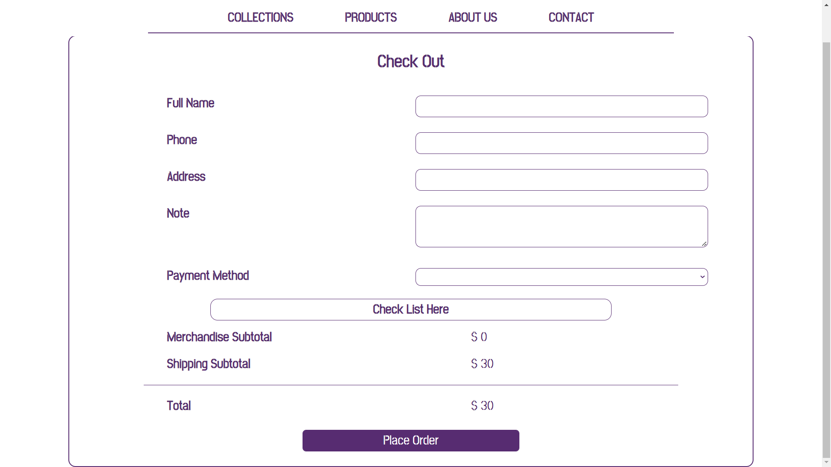

### About us

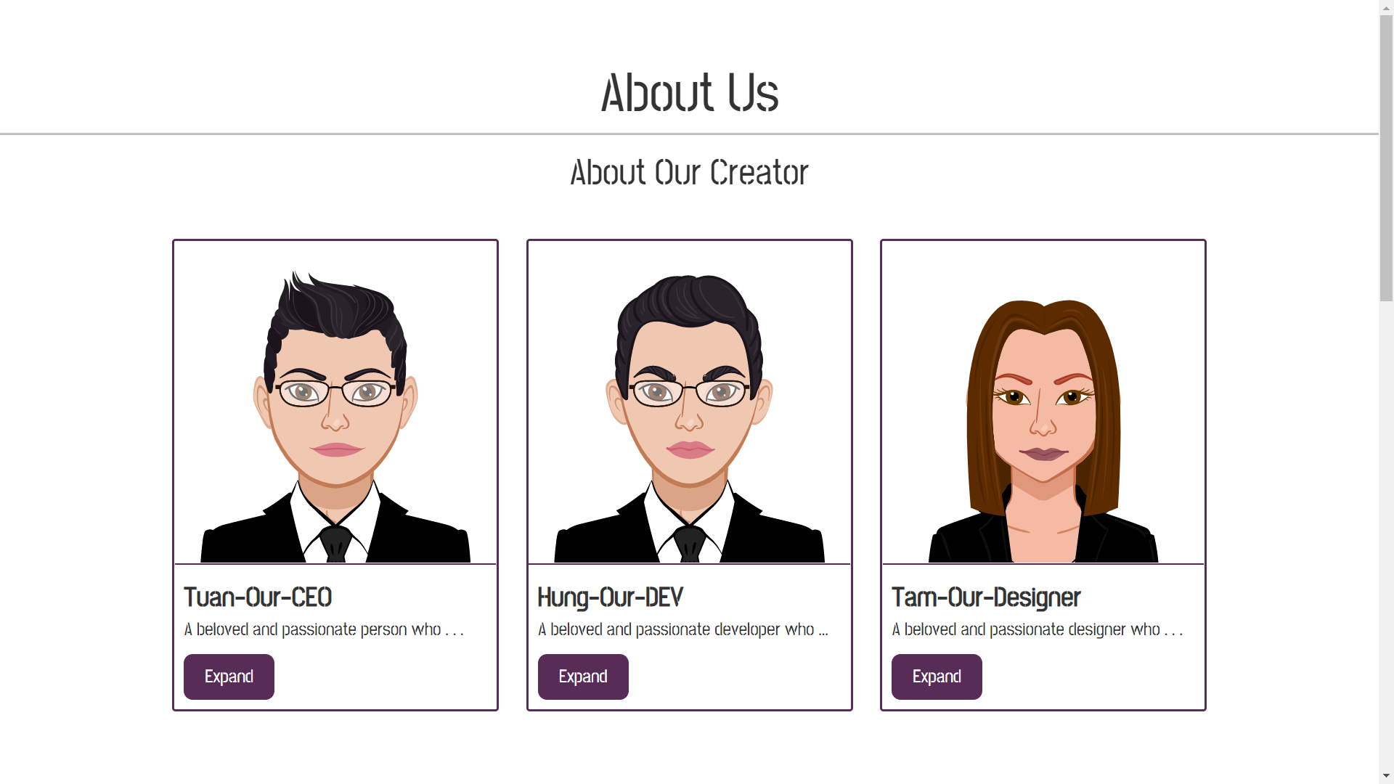

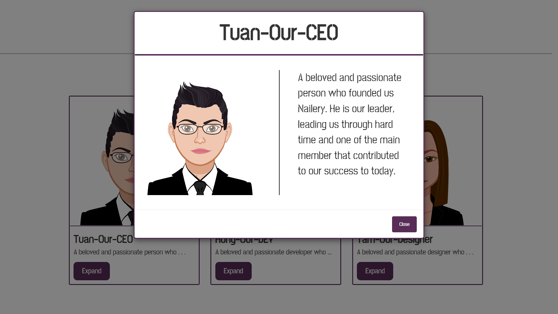

### Contact

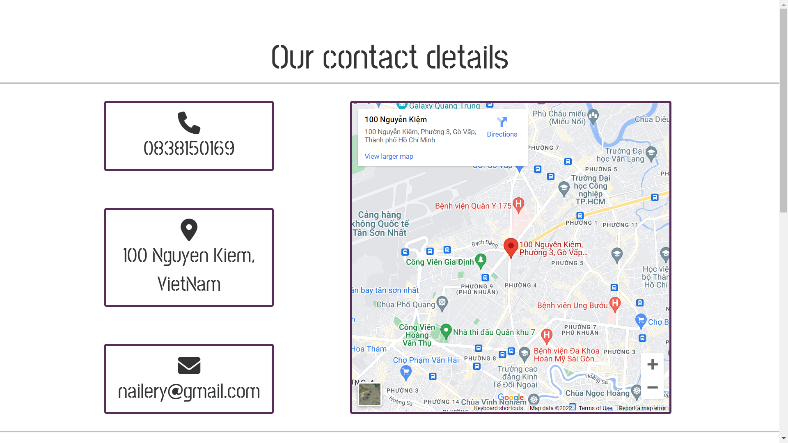

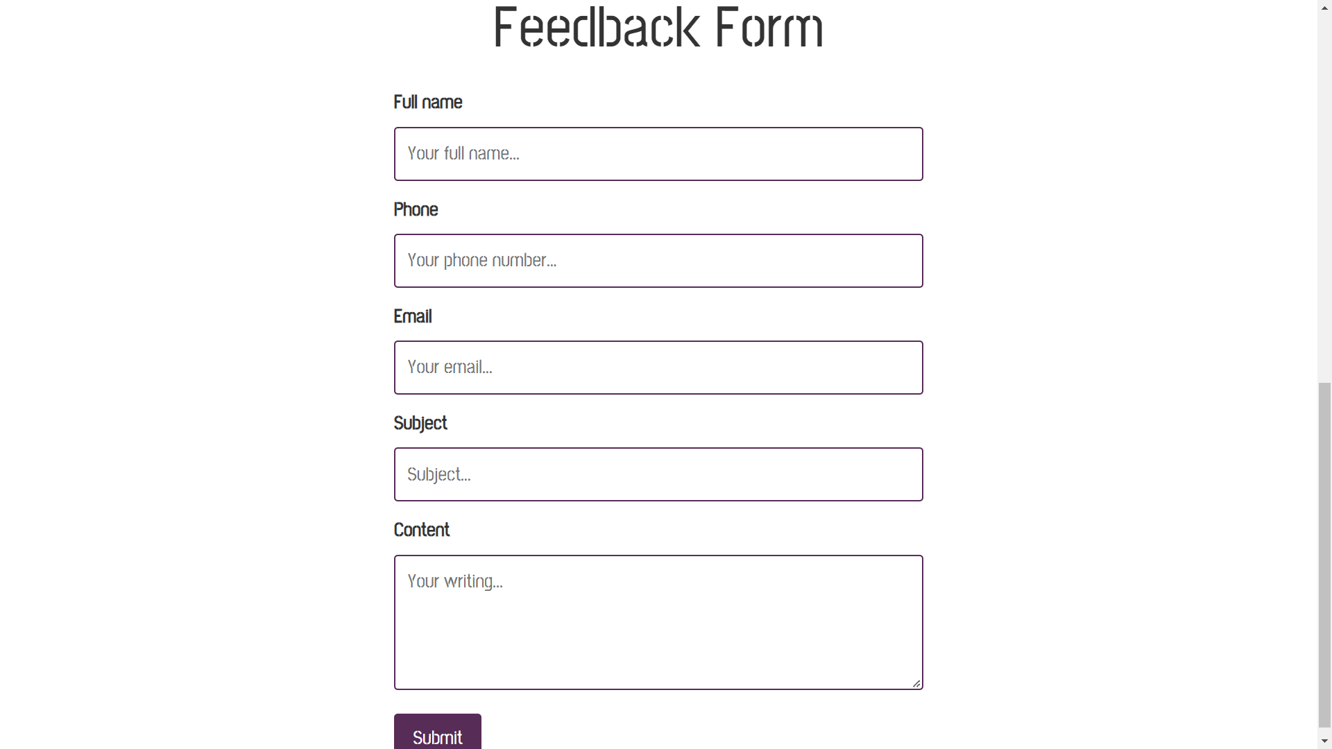

### Sign up

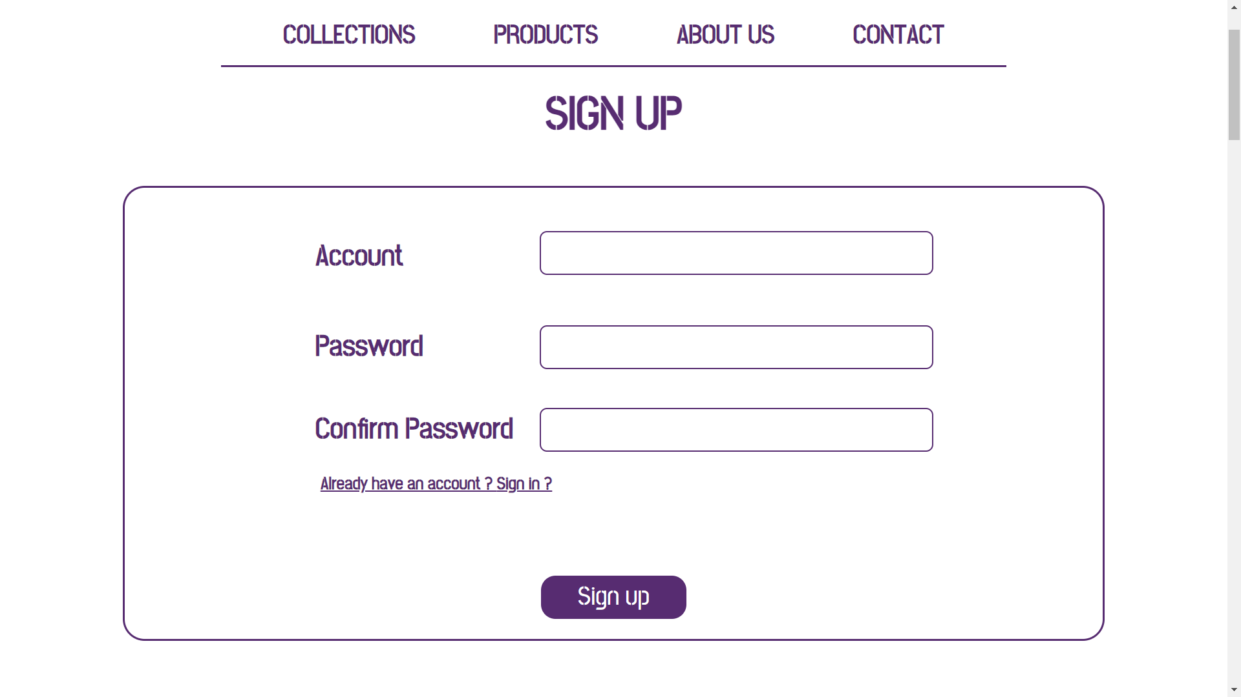

### Sign in

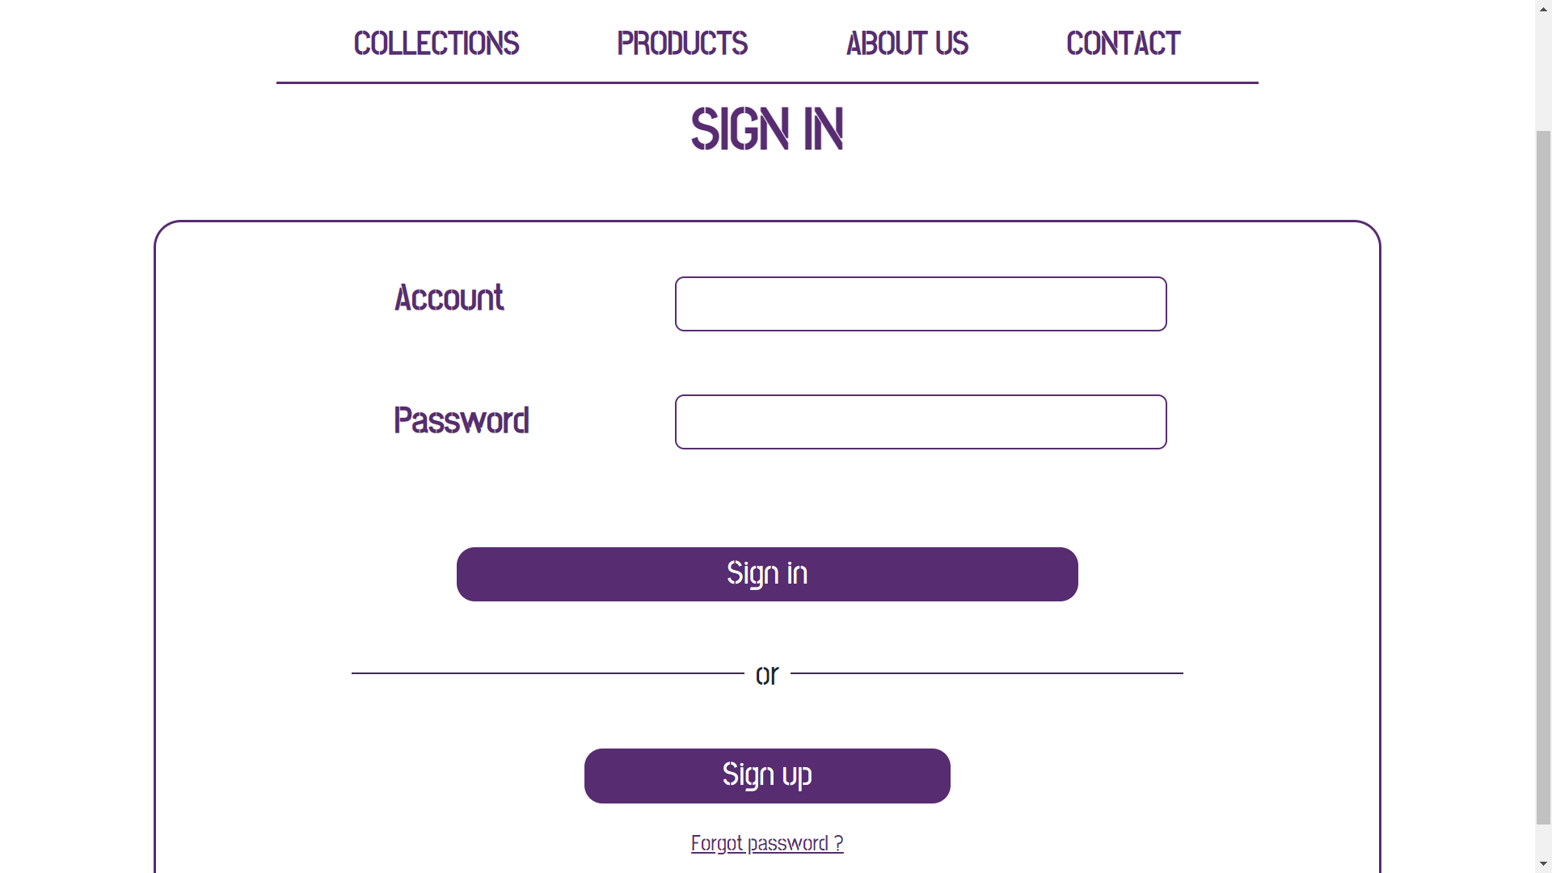

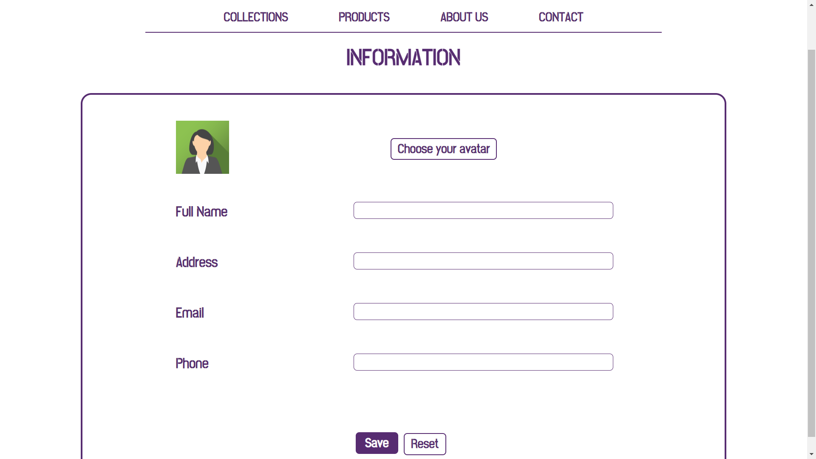

## Task Sheet

|  |  |  |  |  |  |  |
| --- | --- | --- | --- | --- | --- | --- |
| **Project Ref No.** | **Project Title – Ask Me Mobile** | **Activity Plan Prepared by** | **Date of preparation of Activity Plan** | | | |
| **Task** | **Actual Start Date** | **Actual Days** | **Teammate Names** | **Status** |
| Brainstorming ideas for layouts and Project Object | | Hùng,  Tâm,  Tuấn | 01/11/2022 | 3 days | Hùng,  Tâm,  Tuấn | Completed |
| Draw site maps and architecture design | | Hùng,  Tâm,  Tuấn | 04/11/2022 | 7 days | Hùng,  Tâm,  Tuấn | Completed |
| Wire framing general page layout | | Hùng,  Tâm,  Tuấn | 04/11/2022 | 7 days | Hùng,  Tâm,  Tuấn | Completed |
| Collect static assets (pictures, video, documentation, …) | | Hùng,  Tâm,  Tuấn | 04/11/2022 | 7 days | Hùng,  Tâm,  Tuấn | Completed |
| Design & Build Homepage | | Hùng | 11/11/2022 | 10 days | Hùng | Completed |
| Design & Build Collections | | Tâm | 11/11/2022 | 10 days | Tâm | Completed |
| Design & Build Product Category | | Hùng | 11/11/2022 | 10 days | Hùng | Completed |
| Design & Build Cart | | Hùng | 11/11/2022 | 10 days | Hùng | Completed |
| Design & Build About Us | | Tuấn | 11/11/2022 | 10 days | Tuấn | Completed |
| Design & Build Contact | | Tuấn | 11/11/2022 | 10 days | Tuấn | Completed |
| Design & Build Sign In | | Hùng | 11/11/2022 | 10 days | Hùng | Completed |
| Design & Build Check out | | Hùng | 11/11/2022 | 10 days | Hùng | Completed |
| Design & Build Sign Up | | Hùng | 11/11/2022 | 10 days | Hùng | Completed |
| Testing | | Hùng,  Tâm, Tuấn | 22/11/2022 | 7 days | Hùng,  Tâm, Tuấn | Completed |
| Write Project Report | | Hùng,  Tâm | 30/11/2022 | 1 day | Hùng,  Tâm | Completed |

## Testing document

|  |  |  |  |  |
| --- | --- | --- | --- | --- |
| **Sr.No** | **Features Tested** | | | **Remarks** |
| 1 | Are all the users able to view the images and links? | | | OK |
| 2 | Have all the views, modules and controllers been | |  | OK |
| properly integrated and is the site function as a single | | |
| page application? | |  |
| 3 | Are the GUI content devoid of spelling mistakes? | | | OK |
| 4 | Is the application user-friendly? | | | OK |
| 5 | Is the Website launching correctly in all popular | |  | OK |
| browsers? |  |  |
| 6 | Are all the forms validated with proper criteria? | | | OK |
| 7 | Do all text links lead to the appropriate website? | | | OK |
| 8 | Do all image links lead to the appropriate website? | | | OK |
| 9 | Are all the images and links clearly visible on the page? | | | OK |
| 10 | Does the Web page work properly in all the tested | |  | OK |
| browsers? |  |  |
| 11 | Does the Web page take too long to be loaded fully? | | | OK |
| 12 | Is the navigation sequences correct through all the Web | | | OK |
| pages on the site? | |  |
| 13 | Is the JavaScript code working as expected in all click | | | OK |

## Final checklist

|  |  |  |  |  |
| --- | --- | --- | --- | --- |
| **Sr.No** | **Features Tested** | | | **Remarks** |
| 1 | Are all the users able to view the images and links? | | | OK |
| 2 | Have all the views, modules and controllers been | |  | OK |
| properly integrated and is the site function as a single | | |
| page application? | |  |
| 3 | Are the GUI content devoid of spelling mistakes? | | | OK |
| 4 | Is the application user-friendly? | | | OK |
| 5 | Is the Website launching correctly in all popular | |  | OK |
| browsers? |  |  |
| 6 | Are all the forms validated with proper criteria? | | | OK |
| 7 | Do all text links lead to the appropriate website? | | | OK |
| 8 | Do all image links lead to the appropriate website? | | | OK |
| 9 | Are all the images and links clearly visible on the page? | | | OK |
| 10 | Does the Web page work properly in all the tested | |  | OK |
| browsers? |  |  |
| 11 | Does the Web page take too long to be loaded fully? | | | OK |
| 12 | Is the navigation sequences correct through all the Web | | | OK |
| pages on the site? | |  |
| 13 | Is the JavaScript code working as expected in all clicks | | | OK |